Machine Learning

Udemy Notes

**Feature Scaling:**

Feature scaling is a method used to normalize the range of independent variables or features of data.

Scaling the features makes the flow of gradient descent smooth and helps algorithms quickly reach the minima of the cost function. Without scaling features, the algorithm may be biased toward the feature which has values higher in magnitude.

**Standardization:**

$$x_{stand}= \frac{x-min⁡(x)}{standard deviation (x)}$$

A standardized dataset will have a mean of 0 and standard deviation of 1.

**Normalization:**

$x_{norm}= \frac{x - min⁡(x)}{\max\left(x\right)- min⁡(x)}$

The normalized value for the minimum value in the dataset will always be 0. The normalized value for the maximum value in the dataset will always be 1. The normalized values for all other values in the dataset will be between 0 and 1.

**Data Mining Basics:**

* data.head(n)/tail(n) => default n = 5
* data.columns
* data.shape
* data.info()
* data.isna()/isnull().any()/sum()
* data.describe()
* data.replace(0,np.nan)
* data.median()
* data.fillna(data.median(),inplace=True)

NaN (not a number)

* unique, counts = np.unique(data[‘_’], return_counts=True)

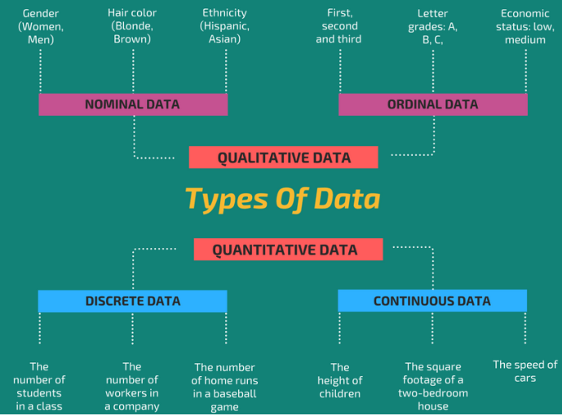

**Important imports:**

* from sklearn.impute import SimpleImputer
* from sklearn.compose import ColumnTransformer
* from sklearn.preprocessing import OneHotEncoder
* ct = ColumnTransformer(transformers = [('encoder', OneHotEncoder(), [1])], remainder = 'passthrough')
* from sklearn.preprocessing import LabelEncoder
* from sklearn.model_selection import train_test_split
* from sklearn.preprocessing import StandardScaler
* from sklearn.linear_model import LinearRegression
* from sklearn.preprocessing import PolynomialFeatures
* from sklrearn.svm import SVR
* from sklearn.tree import DecisionTreeRegressor
* from sklearn.ensemble import RandomForestRegressor
* from sklearn.linear_model import LogisticRegression
* from sklearn.metrics import confusion_matrix, plot_confusion_matrix, accuracy_score
* from sklearn.model_selection import cross_val_score
* from sklearn.neighbors import KNeighborsClassifier
* from sklearn.svm import SVC
* from sklearn.naive_bayes import GaussianNB
* from sklearn.tree import DecisionTreeClassifier
* from sklearn.ensemble import RandomForestClassifier
* from sklearn.cluster import KMeans
* import scipy.cluster.hierarchy as sch
* from sklearn.cluster import AgglomerativeClustering
* !pip install apyori
* from apyori import apriori
* import math {math.sqrt()}
* import random {random.betavariate()}
* import re <= Regular Expression
* import nltk <= Natural Language Toolkit
* from nltk.corpus import stopwords <=nltk.download(‘stopwords’)
* from nltk.stem.porter import PorterStemmer
* from sklearn.feature_extraction.text import CountVectorizer
* import tensorflow as tf
* from keras.preprocessing.image import ImageDataGenerator
* from sklearn.decomposition import PCA
* from sklearn.discriminant_analysis import LinarDiscriminantAnalysis as LDA
* from sklearn.decomposition import KernelPCA
* from sklearn.model_selection import cross_val_score
* from sklearn.model_selection import GridSearchCV
* from xgboost import XGBClassifier / XGBRegressor
* from catboost import CatBoostClassifier / CatBoostRegressor
* import os.path
* import ktrain
* from ktrain import text

**Dataset Library:**

UCI Machine Learning Repository

**Blogs:** [**https://www.superdatascience.com/blogs**](https://www.superdatascience.com/blogs)

**Hyperparameters:** the parameters that are not learned

**Assumptions of Linear Regression:**

* Linearity
* Homoscedasticity
* Multivariate normality
* Independence of errors
* Lack of multicollinearity

**5 methods of building models:**

* All-in
* Backward Elimination
* Forward Selection Stepwise Regression
* Bidirectional Elimination
* Score Comparison

**Backward Elimination**

**Step 1:**

Select a significance level to stay in the model (e.g. SL = 0.05)

**Step 2:**

Fit the full model with all possible predictors

**Step 3:**

Consider the predictor with the highest P-value. If P > SL, go to step 4, otherwise go to FIN

**Step 4:**

Remove the predictor

**Step 5:**

Fit model without this variable

**FIN:**

Model is ready

**Forward Selection**

**Step 1:**

Select a significance level to enter the model (e.g. SL = 0.05)

**Step 2:**

Fit all simple linear regression models **y ~ xn** Select the one with the lowest P value

**Step 3:**

Keep this variable and fit all possible models with one extra predictor added to the one(s) you already have

**Step 4:**

Consider the predictor with the lowest P-value. If P < SL, go to step 3, otherwise go to FIN

**FIN:**

Keep the previous model

**Bidirectional Elimination**

**Step 1:**

Select a significance level to enter and to stay in the model

e.g.: SLENTER = 0.05, SLSTAY = 0.05

**Step 2:**

Perform the step of Forward Selection (new variables must have

P < SLENTER to enter)

**Step 3:**

Perform All steps of Backward Elimination (old variables must have

P < SLSTAY to stay)

**Step 4:**

No new variables can enter and no old variables can exit

**FIN:**

Model is ready

**All Possible Models**

**Step 1:**

Select a criterion of goodness of fit (e.g. Akaike criterion)

**Step 2:**

Construct All Possible Regression Models: 2N -1 combinations

**Step 3:**

Select the one with the best criterion

**FIN:**

Model is ready

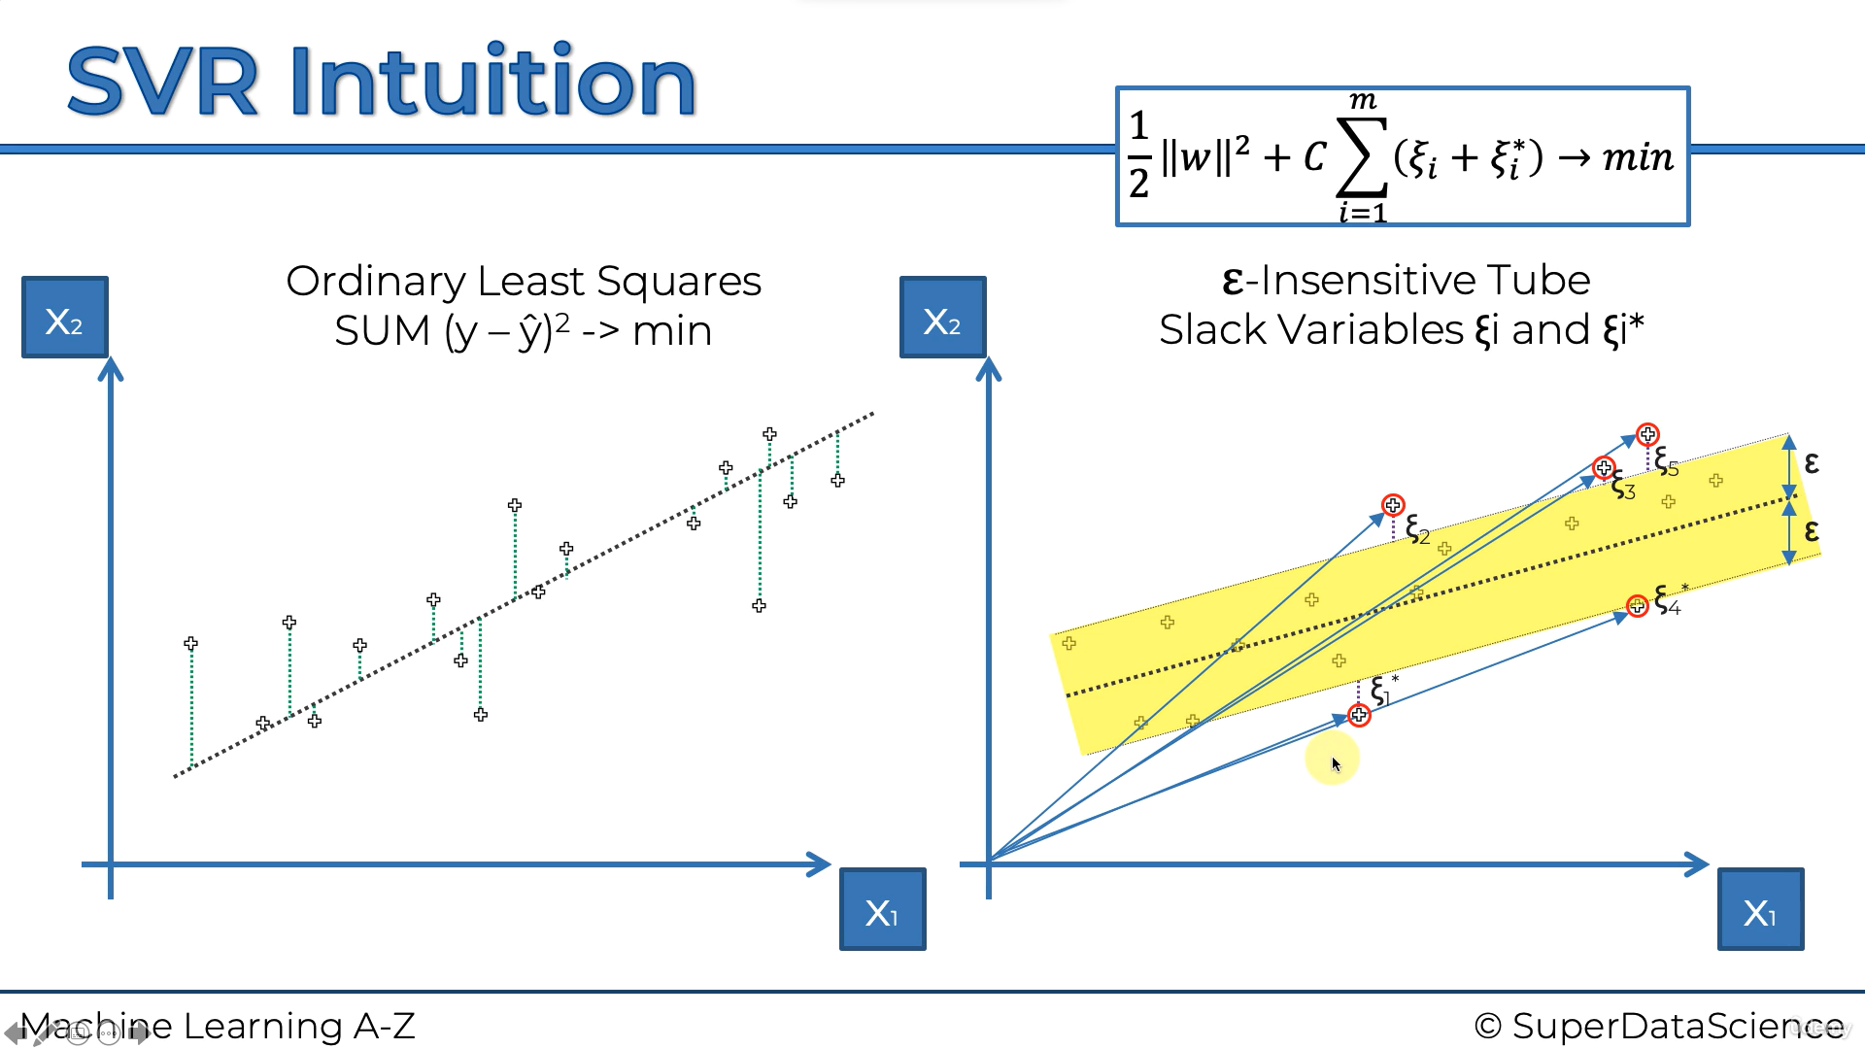

**Feature scaling is compulsory in SVR**

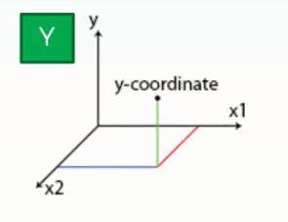**Decision Tree Intuition**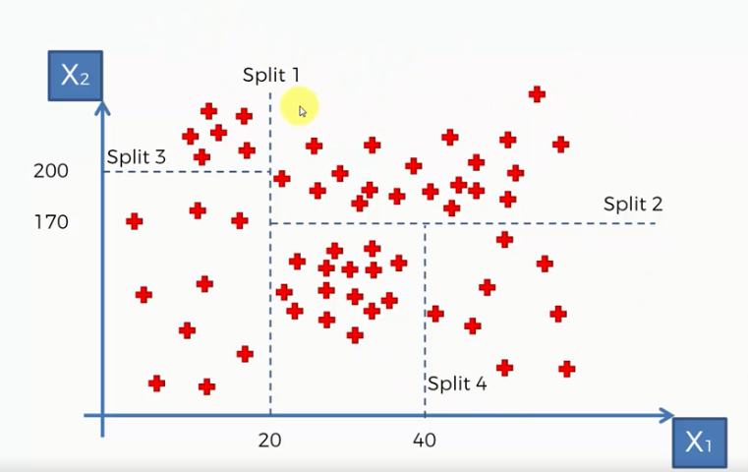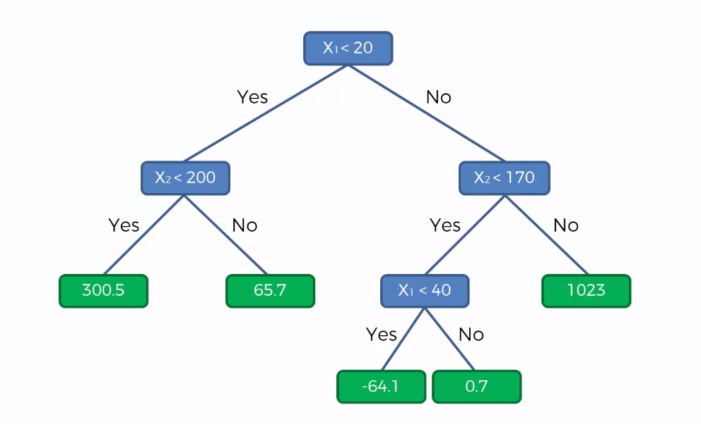

**Random Forest Intuition:**

Step 1:

Pick at random K data points from the Training set

Step 2:

Build the Decision Tree associated to these K data points

Step 3:

Choose the number Ntree of trees you want to build and

repeat Steps 1 & 2

Step 4:

For a new data point, make each one of your Ntree trees predict the value of Y to for the data point in question, and assign the new data point the average across all of the predicted Y values

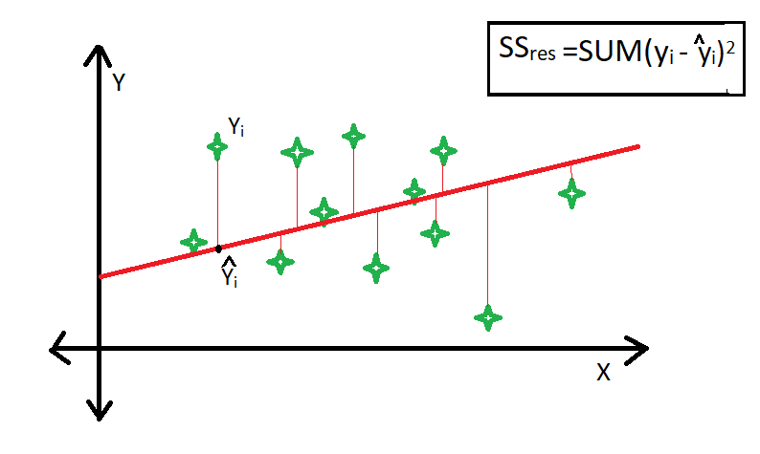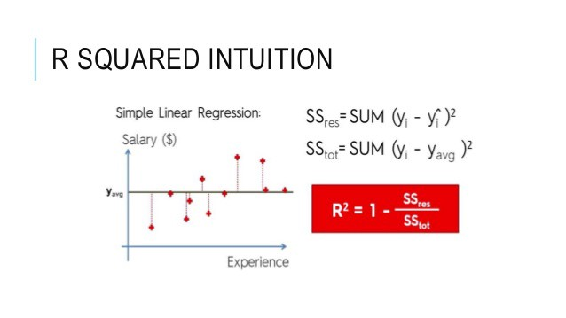

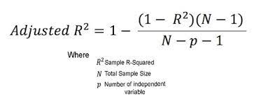

**Logistic Regression**

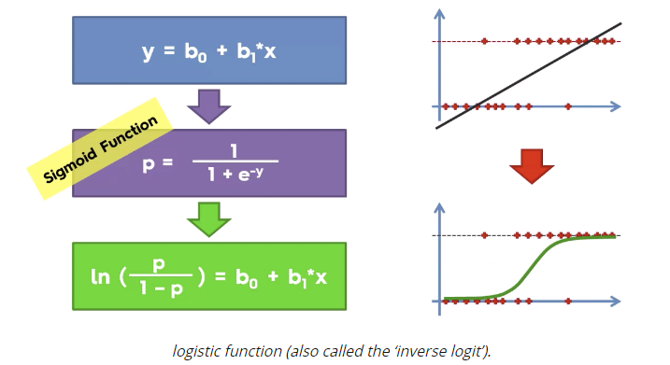

[**The Ultimate Guide to Regression & Classification**](https://www.superdatascience.com/blogs/the-ultimate-guide-to-regression-classification)

**K-Nearest Neighbours (K-NN)**

**Algorithm**

**Step1:**

Choose the number of K neighbours

**Step 2:**

Take the K nearest neighbours of the new data point, according to the Euclidean distance (hypotenuse formula)

**Step 3:**

Among these K neighbours, count the number of data points in each category

**Step 4:**

Assign the new data point to the category where you counted the most neighbours

Model is Ready

**Support Vector Machine (SVM)**

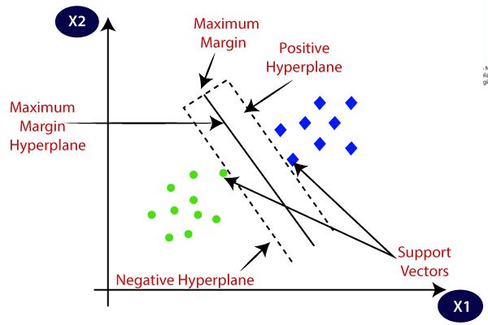

**Kernel SVM**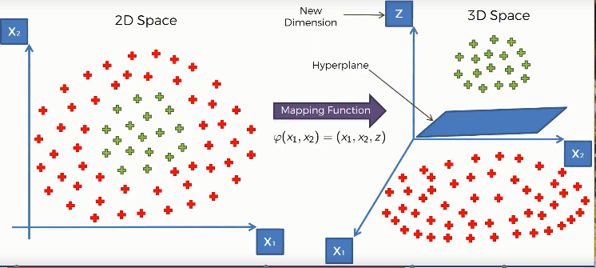

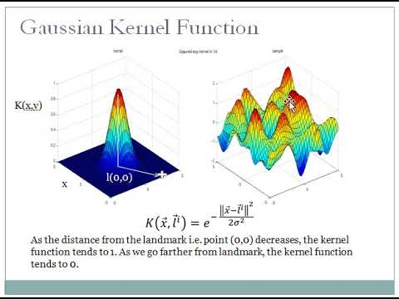

**Bayes Theorem**

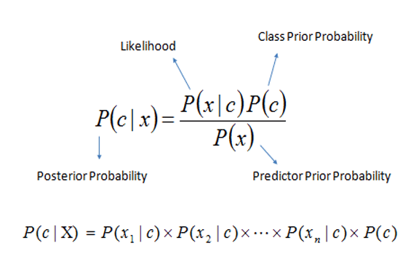

**False Positive & False Negative**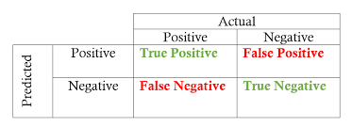

**Confusion Matrix**

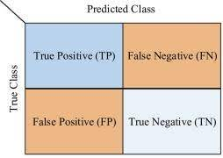

**Accuracy Paradox**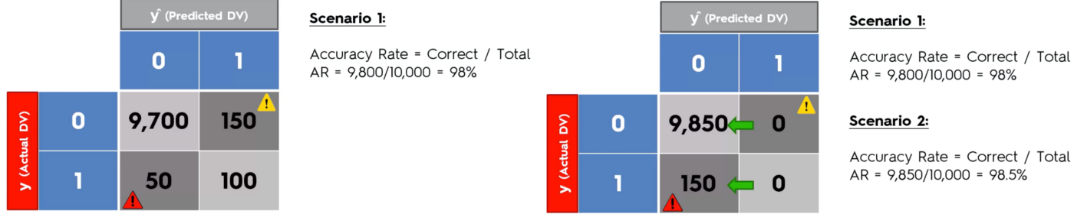

**CAP (Cumulative Accuracy Profile) Curve**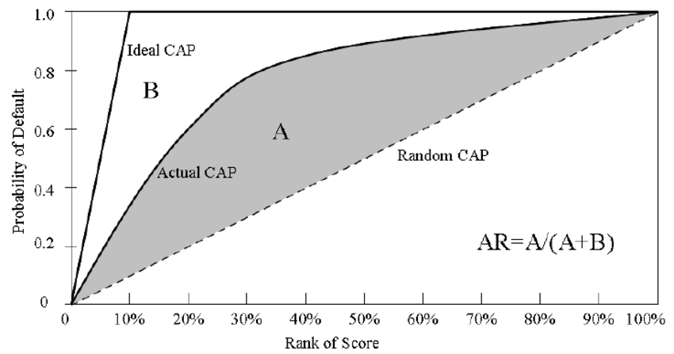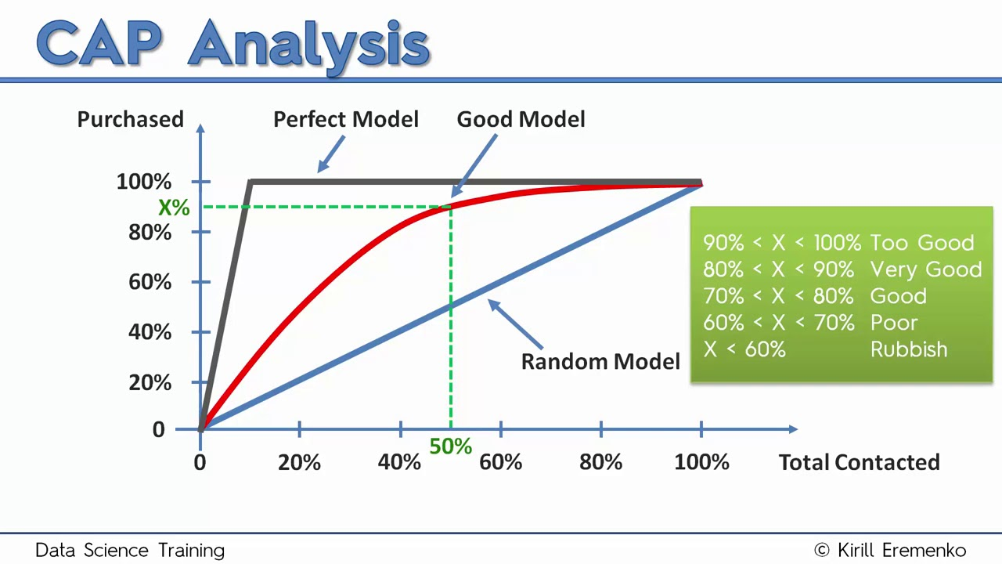

**K-Means Clustering**

**Step 1:**

Choose the number of K clusters

**Step 2:**

Select at random K points, the centroids (not necessarily from your dataset)

**Step 3:**

Assign each datapoint to the closest centroid => That forms K clusters

**Step 4:**

Compute and place the new centroid of each cluster

**Step 5:**

Reassign each data point to the new closest centroid.

If any reassignment took place, go to Step 4, otherwise go to FIN

**FIN :**

Model is ready

Choosing the right number of clusters

Within-Cluster-Sum-of-Squares (WCSS)

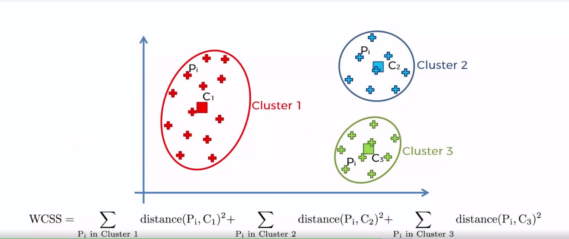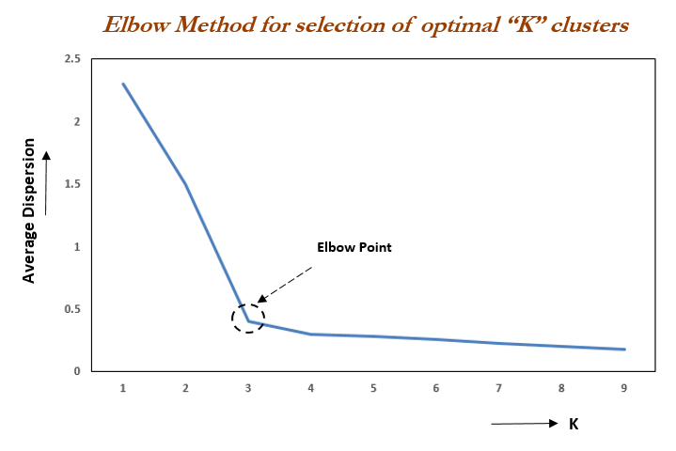

**wcss = kmeans.inertia_**

**kmeans.cluster_centers_**

**Hierarchical Clustering**

**Step 1:**

Make each data point a single-point cluster => that forms N clusters

**Step 2:**

Take the two closest data points and make them one cluster => That forms N – 1 clusters

**Step 3:**

Take the two closest clusters and make them one cluster => That forms N – 2 clusters

**Step 4:**

Repeat step 3 until there is only one cluster

**FIN**

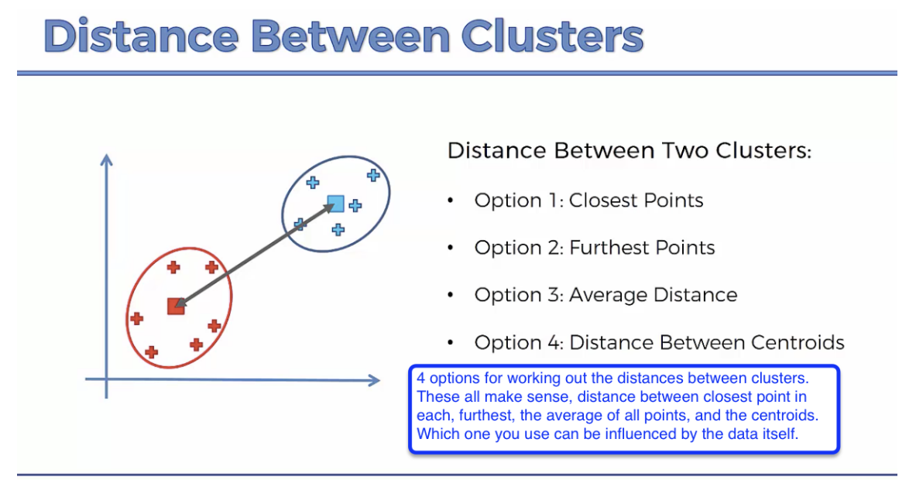 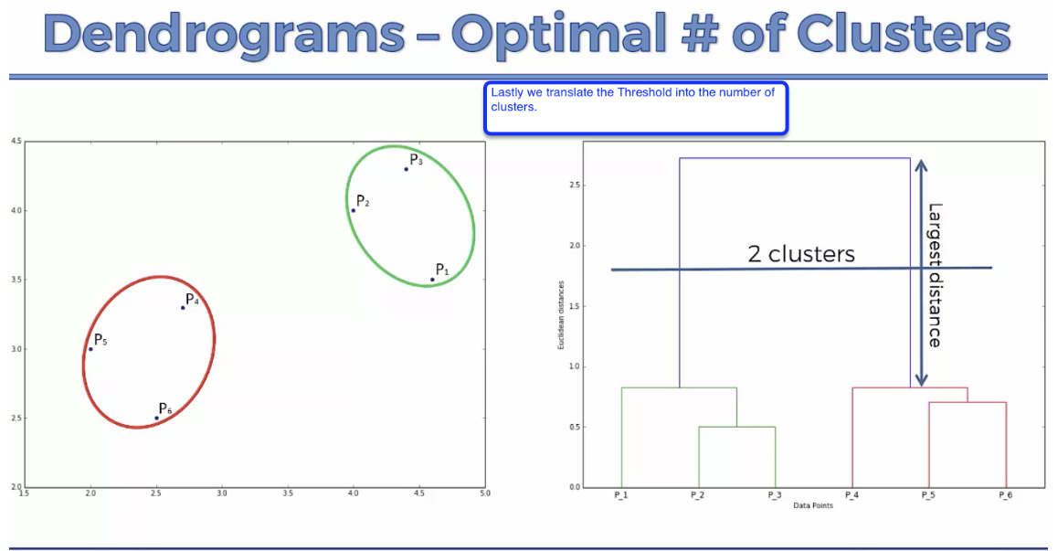

**Association Rule Learning**

**Apriori**

$$Support\left(I\right)= \frac{\#transactions containing I}{\#transactions}$$

$$Confidence\left(I_{1}→I_{2}\right)= \frac{\#transactions containing I_{1} and I_{2}}{\#transactions containing I_{1}}$$

$$Lift = \frac{Confidence}{Support}$$

**Step 1:**

Set a minimum support and confidence

**Step 2:**

Take all the subsets in transactions having higher supportthan minimum support

**Step 3:**

Take all the rules of these subsets having higher confidence than minimum confidence

**Step 4:**

Sort the rules by decreasing lift

**Eclat**

**Step 1:**

Set a minimum support

**Step 2:**

Take all the subsets in transactions having higher support than minimum support

**Step 3:**

Sort these subsets by decreasing support

**Reinforcement Learning**

**Upper Confidence Bound (UCB)**

Explore and Exploit

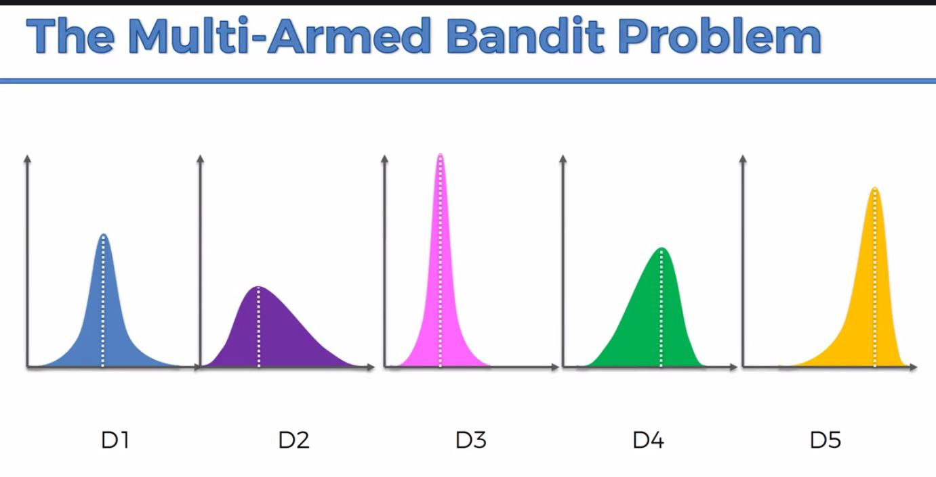

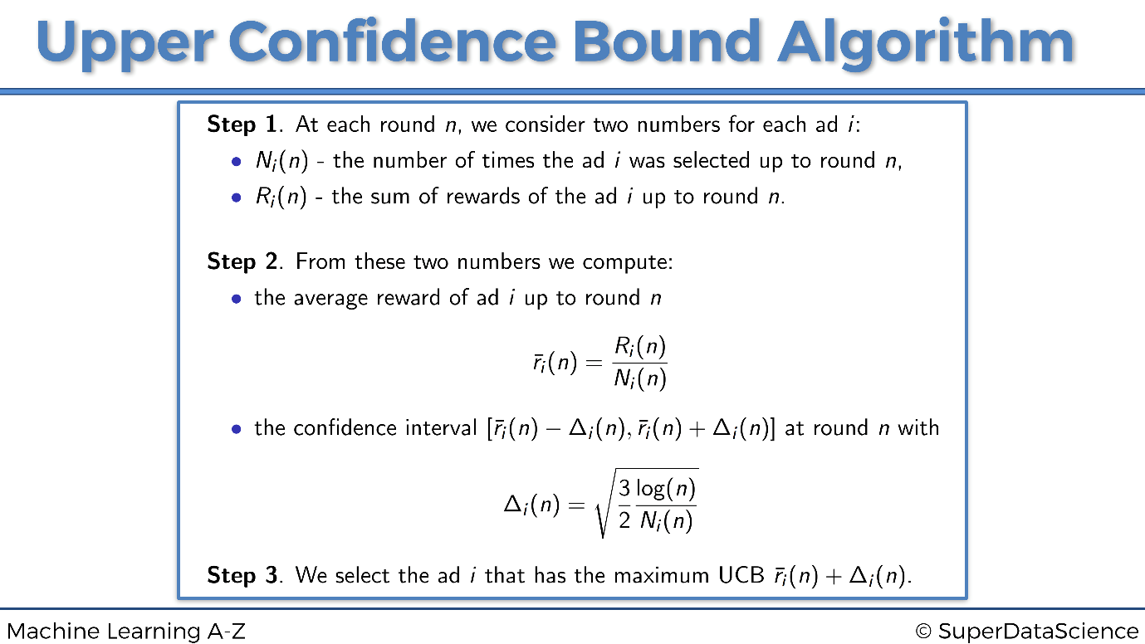

**Thompson Sampling**

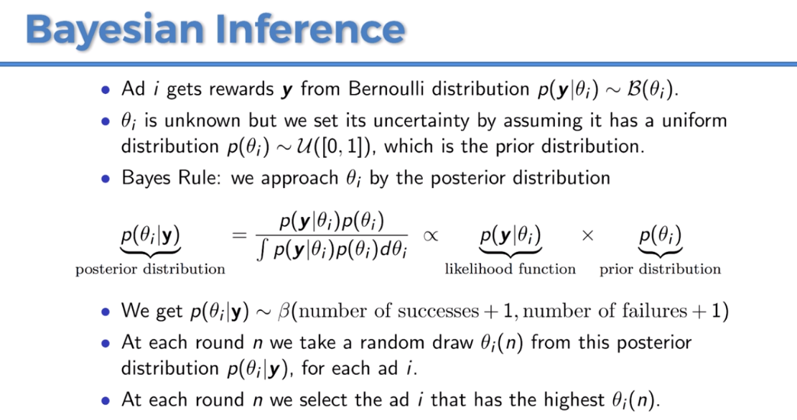

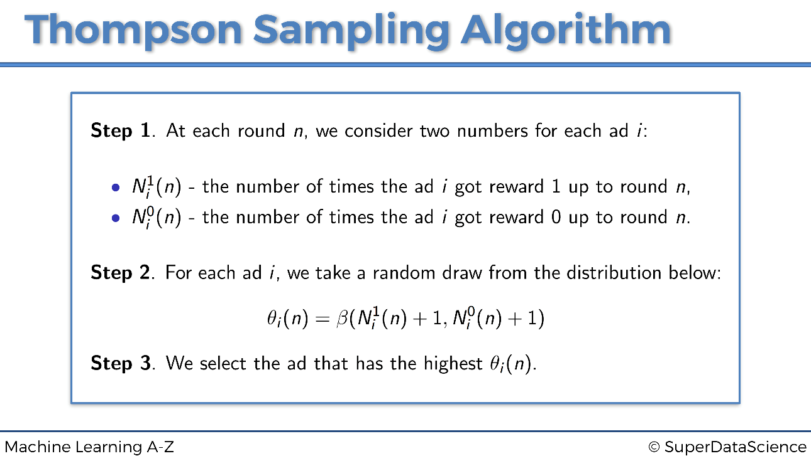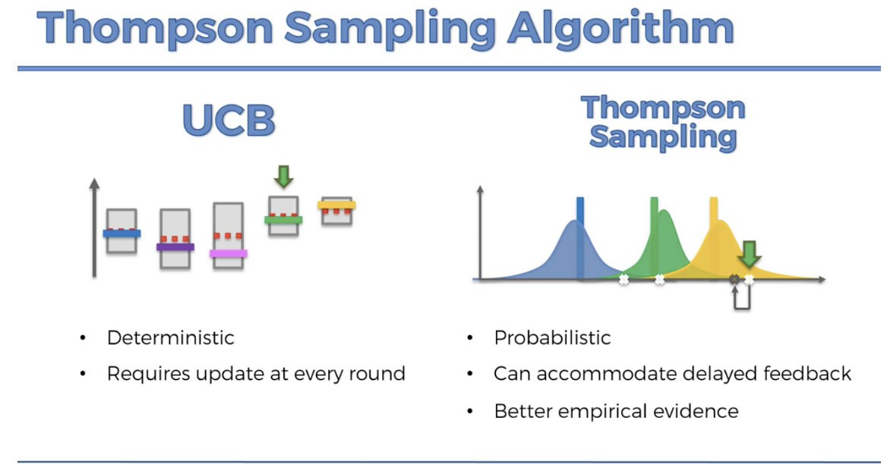

**Natural Language Processing (NLP)**

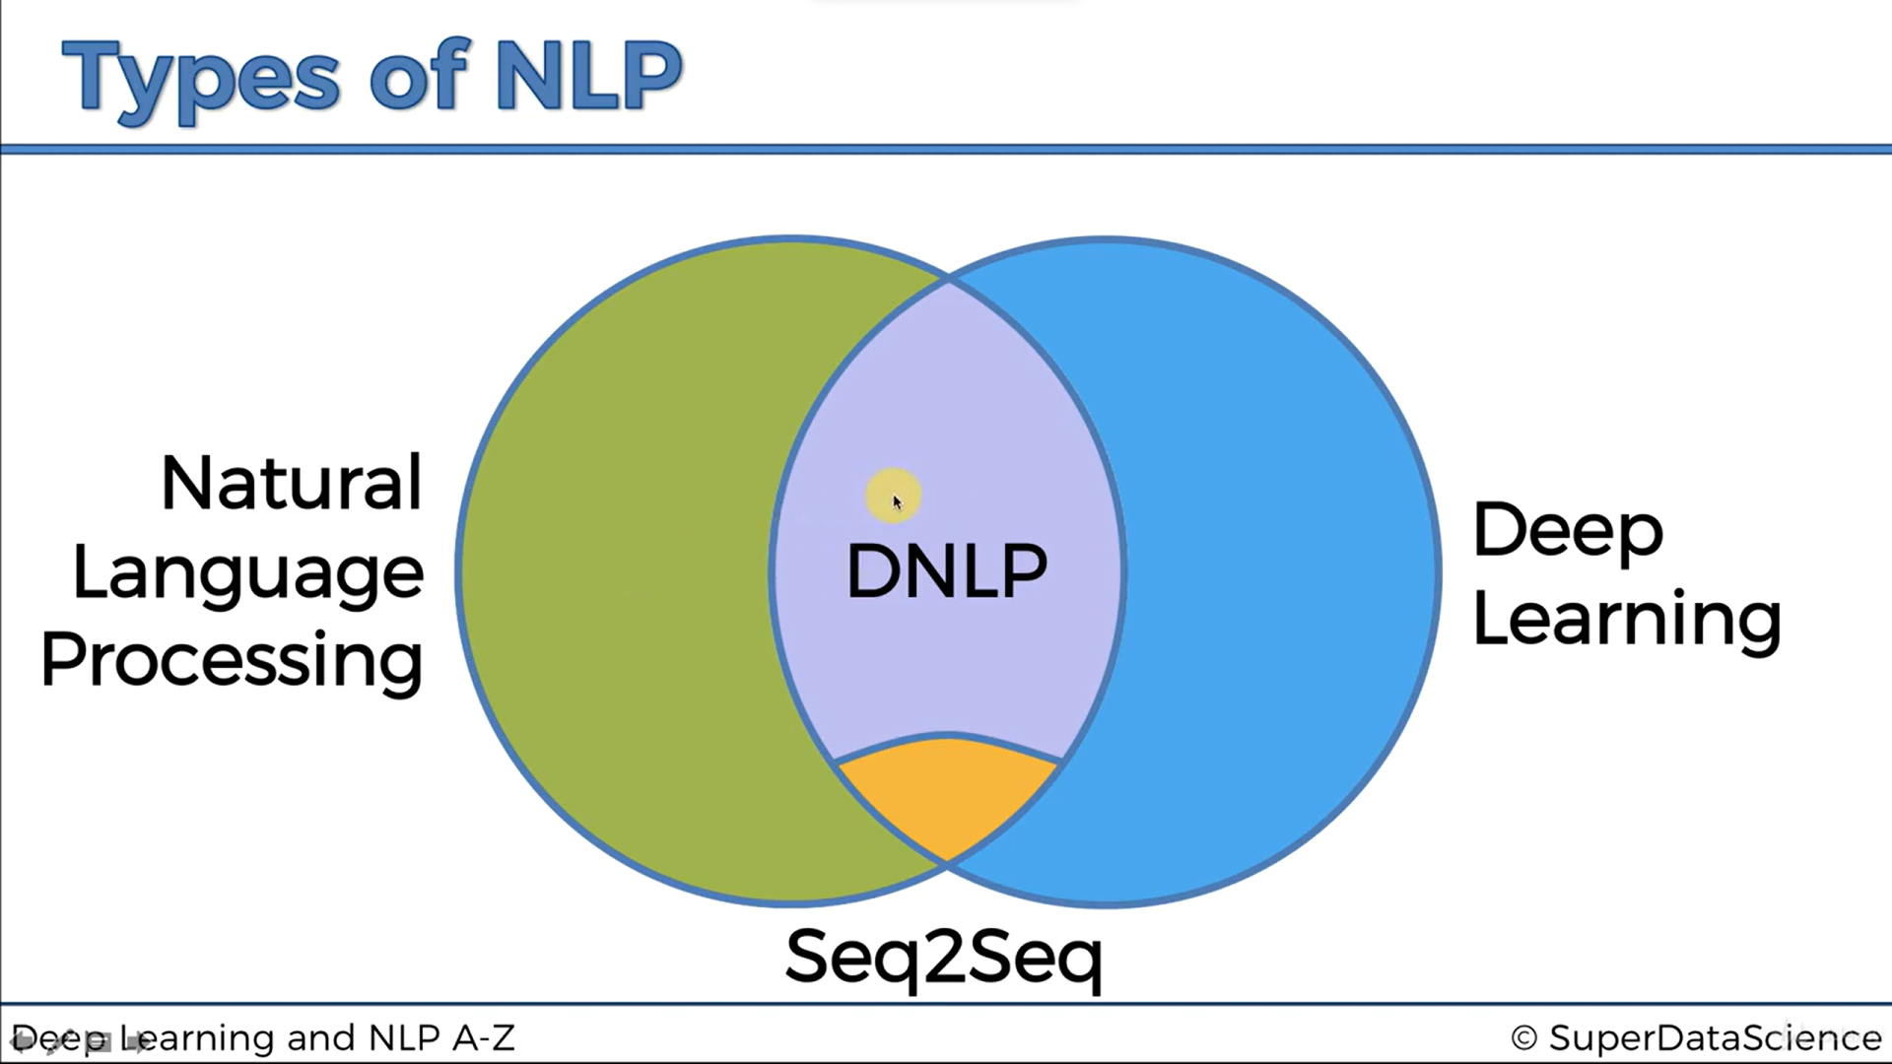

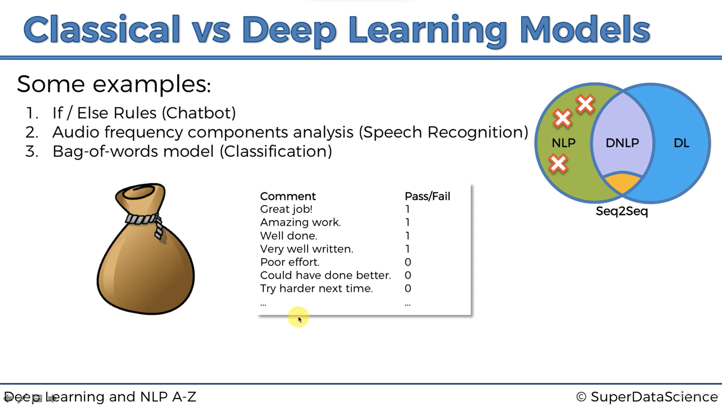

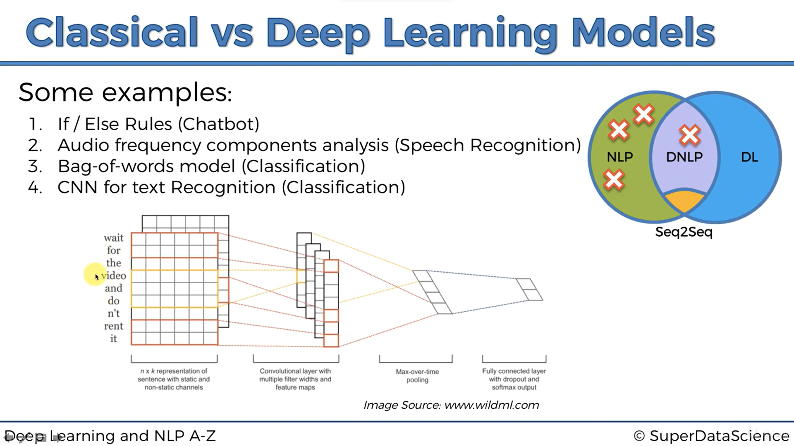

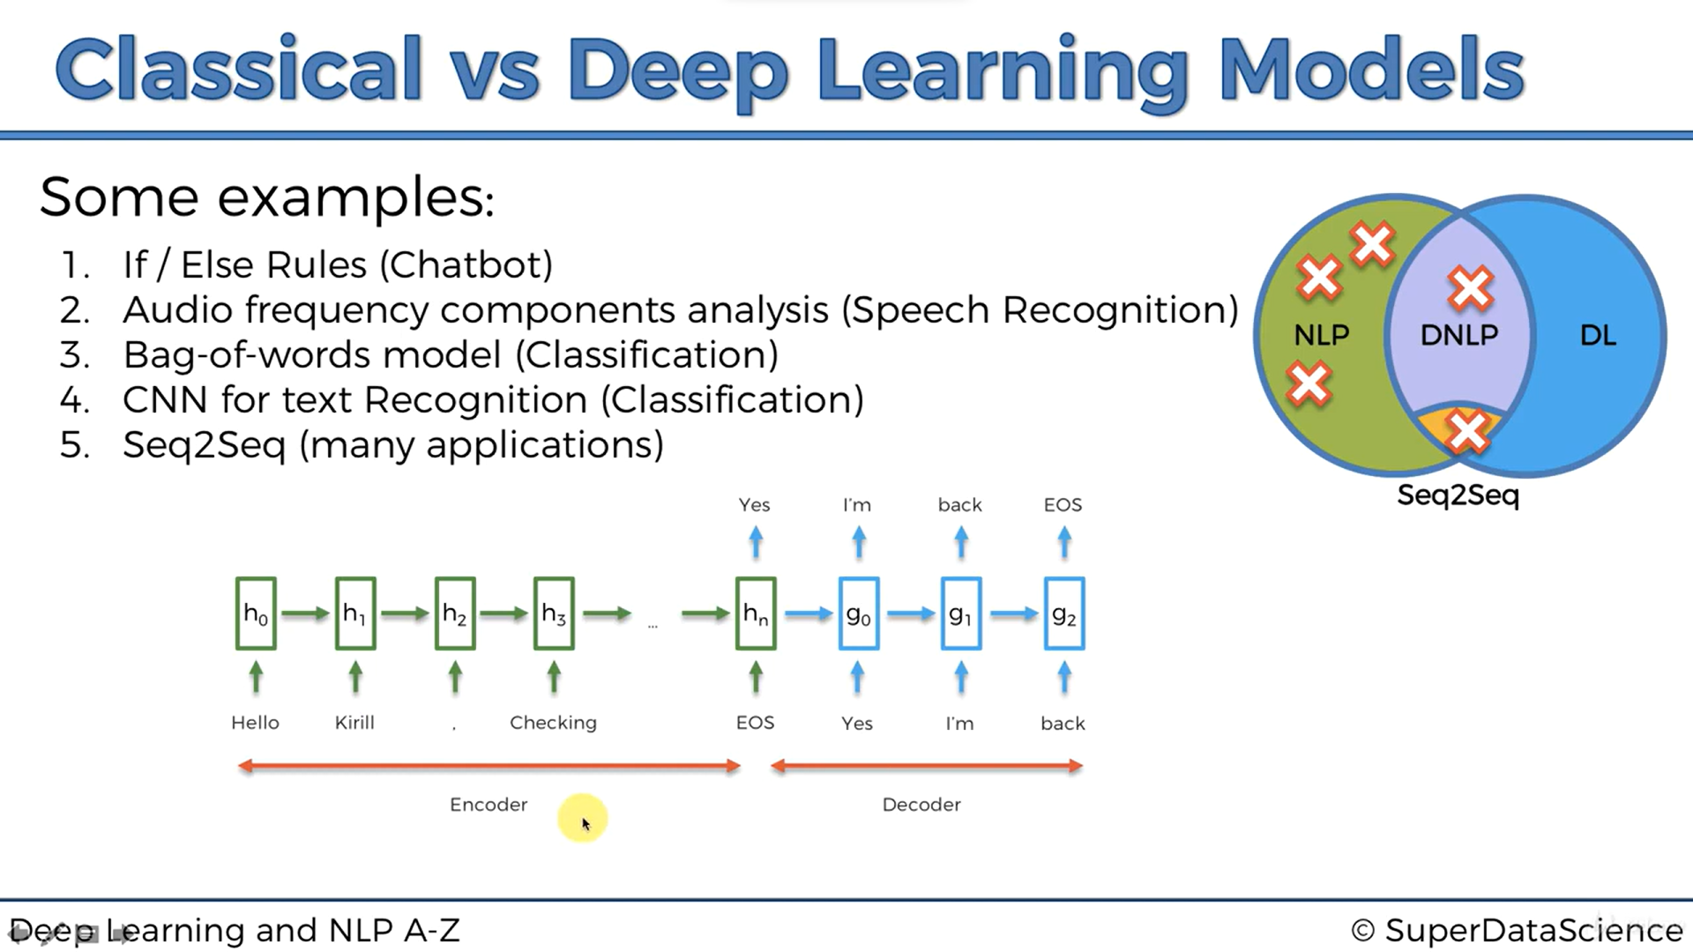

SOS (Start of sentence)

EOS (End of sentence)

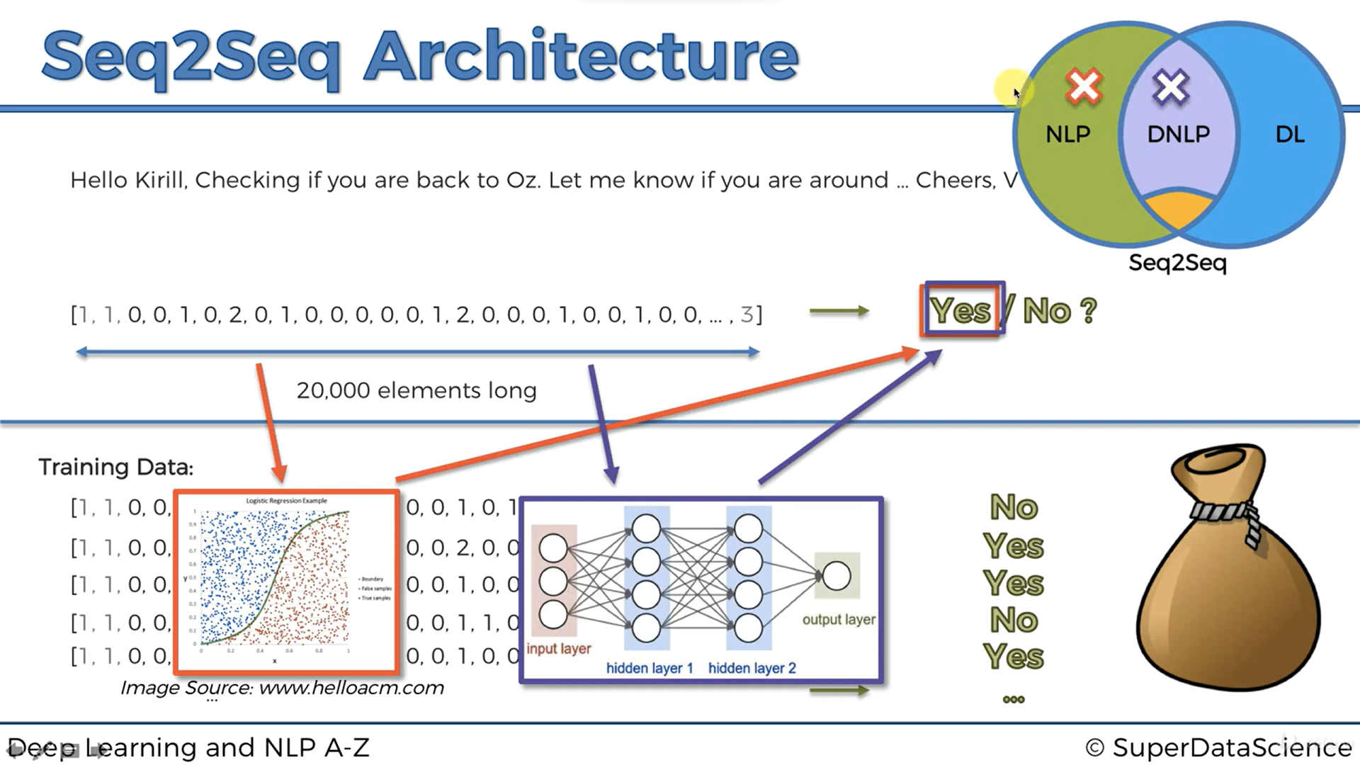

Accuracy is not enough, so you should also look at other performance metrics like Precision (measuring exactness), Recall (measuring completeness) and the F1 Score (compromise between Precision and Recall). Please find below these metrics formulas (TP = # True Positives, TN = # True Negatives, FP = # False Positives, FN = # False Negatives):

Accuracy = (TP + TN) / (TP + TN + FP + FN)

Precision = TP / (TP + FP)

Recall = TP / (TP + FN)

F1 Score = 2 * Precision * Recall / (Precision + Recall)

Try even other classification models

Good ones for NLP include:

* CART
* C5.0
* Maximum Entropy

**BERT (Bidirectional Encoder Representations from Transformers)**

<https://sdsclub.com/bert-google-nlp-algorithm/>

**Deep Learning**

Father of Deep Learning: **Geoffrey Hinton**

**Artificial Neural Network**

[**The Ultimate Guide to Artificial Neural Networks (ANN)**](https://www.superdatascience.com/blogs/the-ultimate-guide-to-artificial-neural-networks-ann)

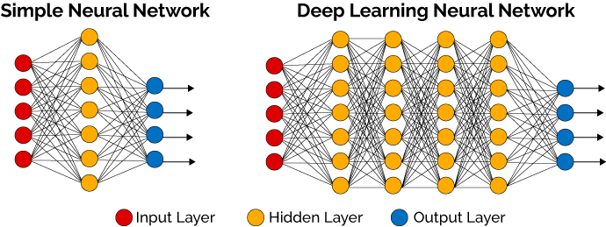

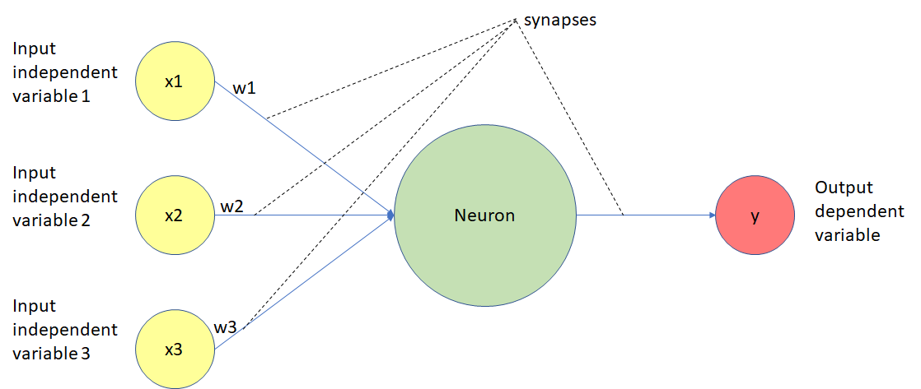

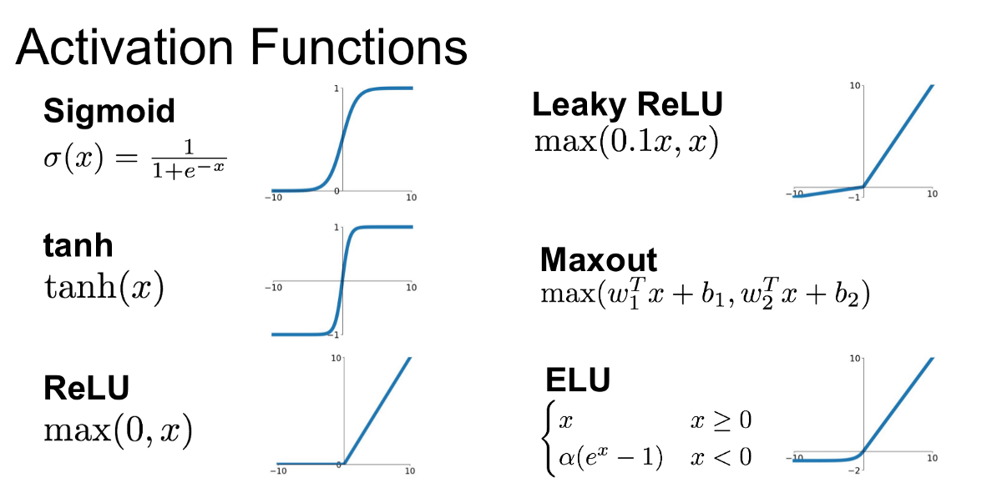

Rectified Linear Unit (ReLU)

Exponential Linear Unit (ELU)

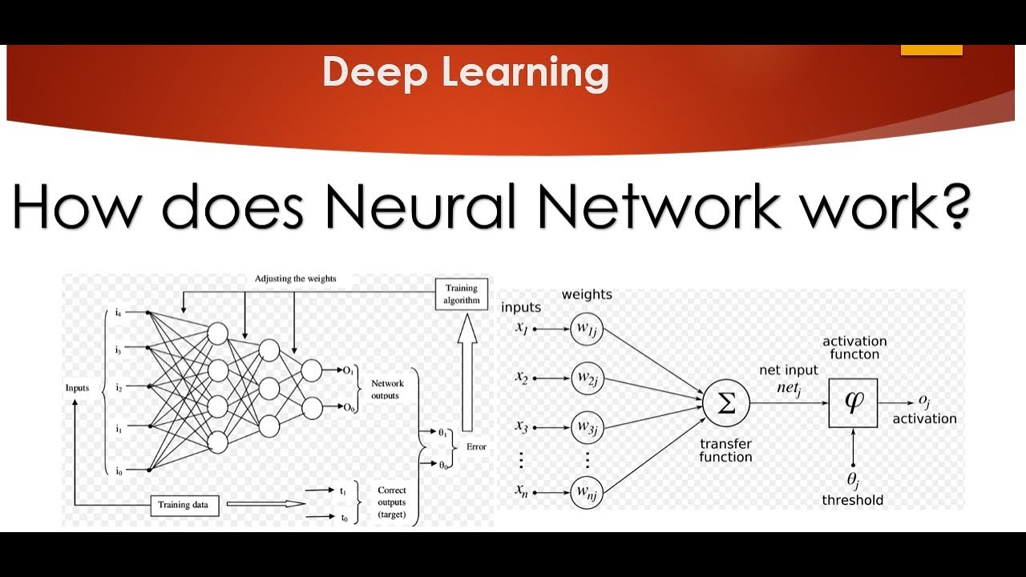

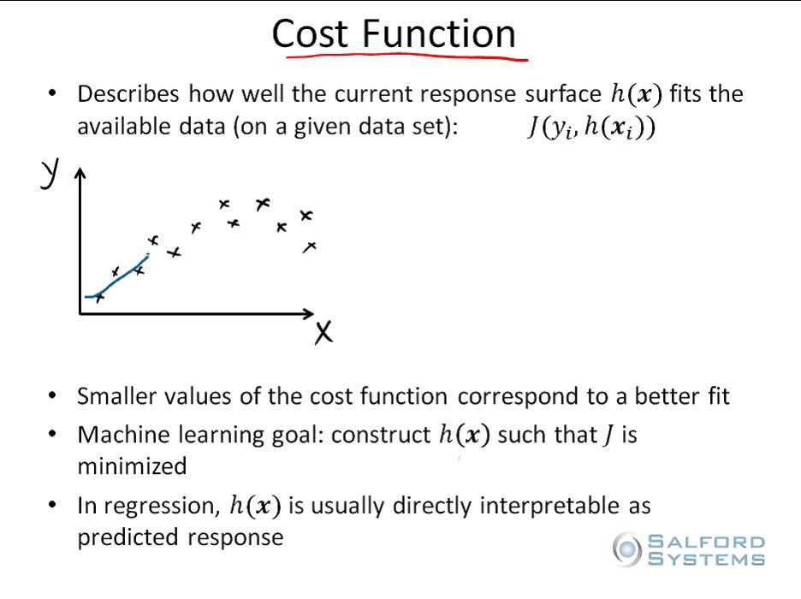

**Sunway TaihuLight: World’s fastest Super Computer**

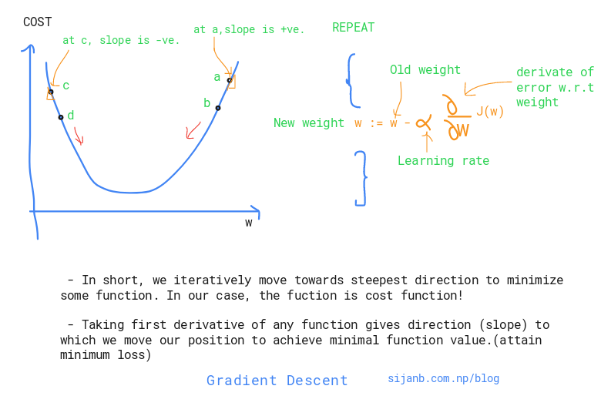

**Batch & Stochastic Gradient Descent**

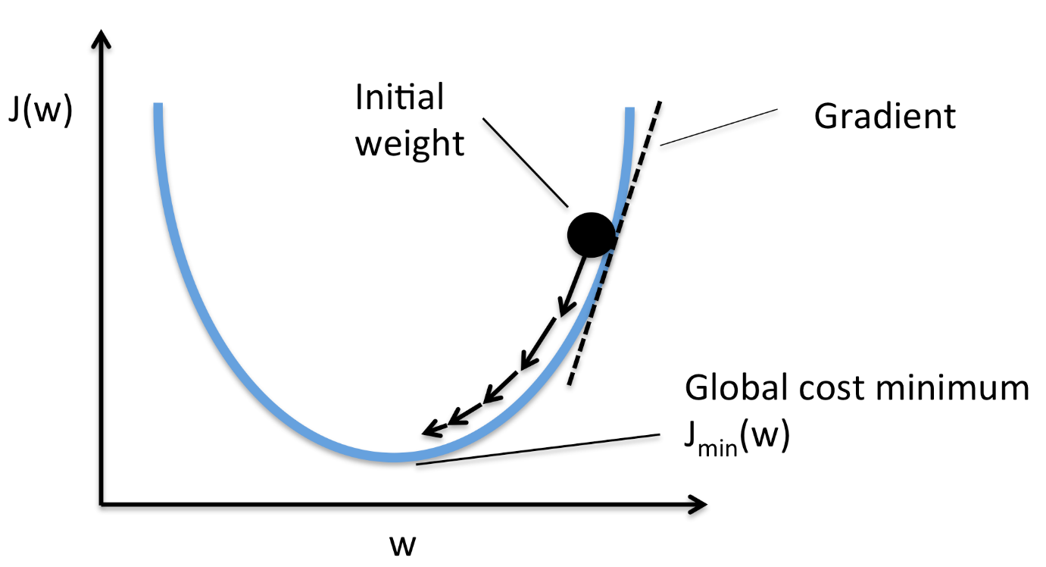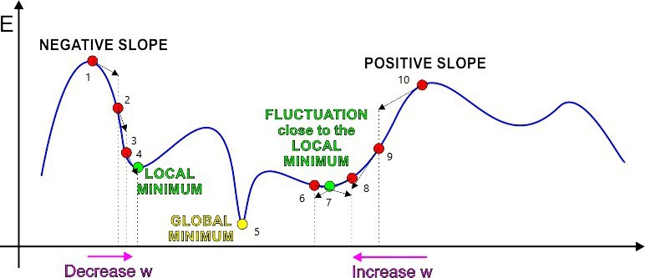

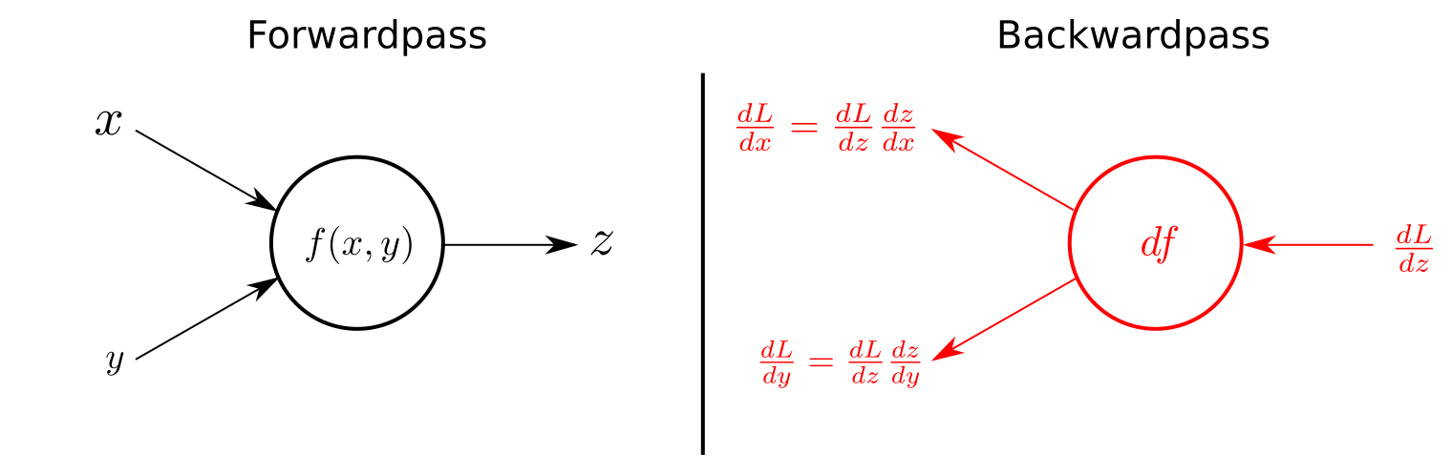

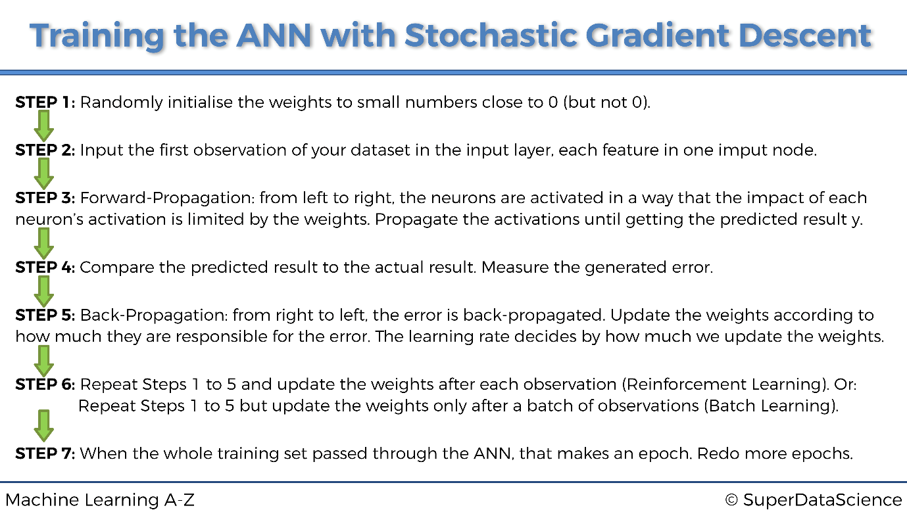

ann = tf.keras.models.Sequential()

ann.add(tf.keras.layers.Dense(units = n, activation = ‘’))

**Convolutional Neural Network**

Father of Deep Learning: **Yann Lecun** (student of **Geoffrey Hinton**)

Facebook Google

**Step 1:** Convolution

**Step 2:** Max Pooling

**Step 3:** Flattening

**Step 4:** Full Connection

<http://yann.lecun.com/exdb/publis/pdf/>

[The Ultimate Guide to Convolutional Neural Networks (CNN)](https://www.superdatascience.com/blogs/the-ultimate-guide-to-convolutional-neural-networks-cnn)

<https://www.cs.cmu.edu/~aharley/vis/conv/flat.html>

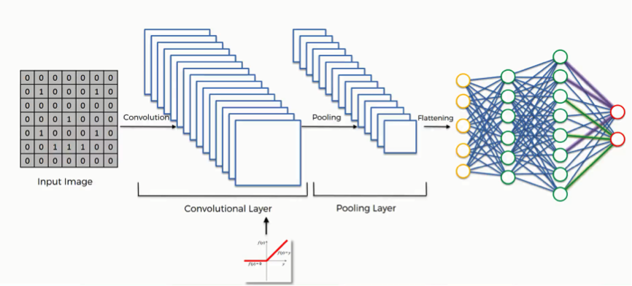

cnn = tf.keras.models.Sequential()

cnn.add(tf.keras.layers.Conv2D(filters = n, kernel_size = n, activation = ‘’))

cnn.add(tf.keras.layers.MaxPool2D(pool_size = n, strides = n))

cnn.add(tf.keras.layers.Flatten())

cnn.add(tf.keras.layers.Dense(units = n, activation = ‘’))

**Dimensionality Reduction**

**Principal Component Analysis (PCA)**

(unsupervised)

<https://setosa.io/ev/principal-component-analysis/>

**Linear Discriminant Analysis (LDA)**

(supervised)

<https://sebastianraschka.com/Articles/2014_python_lda.html>

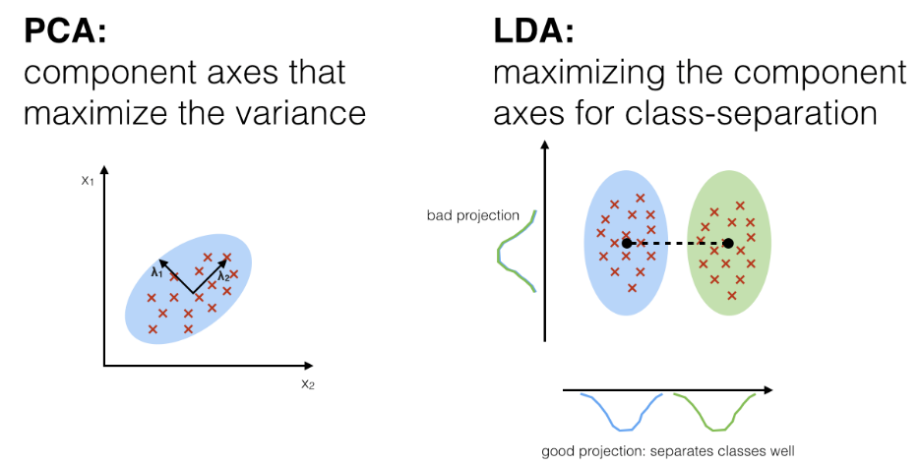

**XGBoost (Extreme Gradient Boosting)**

